# Bone Segmentation for Lateral Knee Images: User Manual

By Lu Yik Ho

# Introduction

This bone segmentation program aims to generate mask images for each bone in a lateral knee X-ray image, particularly the patella, femur and tibia.

The program mainly features the YOLO Version 11 Segmentation Nano Model by Ultralytics, applying the model to segment the region of interest from the image, and LabelMe, a free-to-use Python software that has an easy image labelling process.

The Jupyter Notebook program also contains image preparation, data compiler, model training, inference tools and model application to generate mask images.

This user manual aims to be a comprehensive guide of the program, explaining the details of the functions used in the program, while demonstrating the usage by providing sample input parameter values and expected outputs.

This project is a direct continuation of the Knee Detection project.

Knee Detection Project: <https://github.com/Lu-Yik-Ho/Knee-Lateral-Xray-RoI-Detection-Model-Program>

# 

# 

# Table of Contents:

**Bone Segmentation for Lateral Knee Images: User Manual 1**

**Introduction 1**

**Table of Contents: 2**

**Step 1: Program Requirements 2**

1.1 Required Python Files 3

1.2 Suggested Directories 4

1.3 Required Python Modules 5

1.4 Installing LabelMe 6

**Step 2: Preparing Images for LabelMe 7**

2.1 Retrieving and Flipping Images from DICOM Files 7

2.2 Cropping Images into Squares 9

2.3 Processing Square Images 11

**Step 3: Creating Bounding Boxes with LabelMe 13**

3.1 Initialising LabelMe 13

3.2 Opening Image Directory 14

3.3 Drawing Polygon Bounding Box 15

3.4 Saving Bounding Box 16

**Step 4: Creating YOLO Required Dataset 17**

4.1 Splitting Training and Inference Images 18

4.2 Creating YOLO Dataset 18

4.4 Creating YOLO YAML file 20

**Step 5: Fine-tuning YOLO Model 21**

5.1 Fine-Tuning New Model 21

5.2 Re-training Trained Model 23

5.3 Interpreting Training Results 24

**Step 6: Inference with Tuned Model 29**

6.1 Running Inference 29

**Step 7: Creating Mask Images with Tuned Model 32**

7.1 Creating Mask Images 32

**Conclusion 33**

**Acknowledgement: 33**

# Step 1: Program Requirements

This program requires preinstalled modules. This step provides a guide on the required modules.

## 1.1 Required Python Files

The BoneSegmentationLateral_v1.1_main Jupyter Notebook imports all functions from the BoneSegmentationLateral_ImageProcessing.py and BoneSegmentationLateral_TrainYoloModel.py files. Additionally, SquareCroppingModel.pt is provided to crop the images to the region of interest.

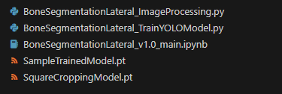

*Figure 1.1.1 Required Python Files Placed under Main Folder*

Please ensure these four files are located in the main folder.

This program was run and tested in Visual Studio Code, within a virtual environment in Python 3.13.5.

A GPU is required to operate PyTorch. For this demonstration, CUDA 12.6 was used.

## 

## 1.2 Suggested Directories

The program can support most types of directory or folder structures.

However, it is recommended to follow this directory structure to help keep files separate.

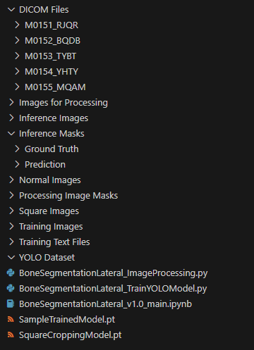

*Figure 1.2.1 Suggested Main Folder Structure*

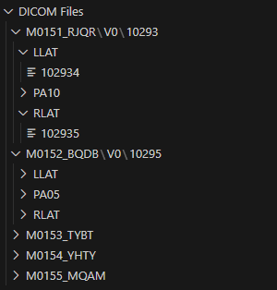

*Figure 1.2.2 Suggested DICOM Files Folder Structure*

The user manual and the following demonstrations will follow this folder structure.

## 1.3 Required Python Modules

These are the required modules used:

Under Python Standard Library:

* os: <https://docs.python.org/3/library/os.html>
* glob: <https://docs.python.org/3/library/glob.html>
* shutil: <https://docs.python.org/3/library/shutil.html>

Installation required:

* torch: <https://pytorch.org/>
* torchvision: <https://pypi.org/project/torchvision/os>
* matplotlib: <https://matplotlib.org/>
* cv2: <https://pypi.org/project/opencv-python/>
* PIL: <https://pillow.readthedocs.io/en/stable/>
* numpy: <https://numpy.org/>
* ultralytics: <https://docs.ultralytics.com/quickstart/>

Run the “Step 1.3” section once when starting the Jupyter kernel to confirm all modules are installed and can be successfully imported.

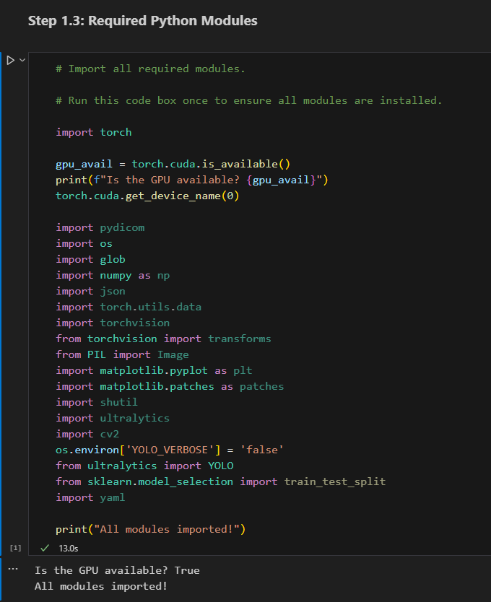

*Figure 1.3.1 “Step 1.3” Section and Expected Output*

## 1.4 Installing LabelMe

The program specifically requires bounding boxes generated by LabelMe.

It is recommended to use Anaconda Package Manager to install LabelMe due to the large number of dependencies.

Anaconda Download: <https://www.anaconda.com/download>

LabelMe Install Instructions: <https://labelme.io/docs/install-labelme-pip>

# 

# Step 2: Preparing Images for LabelMe

These steps retrieve images from DICOM files, cropping said images into squares and applying post-processing to enhance model training.

These steps are imported directly from the KneeDetectionLateral project. For more information about these steps, please refer to <https://github.com/Lu-Yik-Ho/Knee-Lateral-Xray-RoI-Detection-Model-Program>.

The training images and inference images should not be split yet to process all images at once.

## 2.1 Retrieving and Flipping Images from DICOM Files

This step retrieves images in PNG format from DICOM files and flips the right knee images horizontally to produce more left knee images.

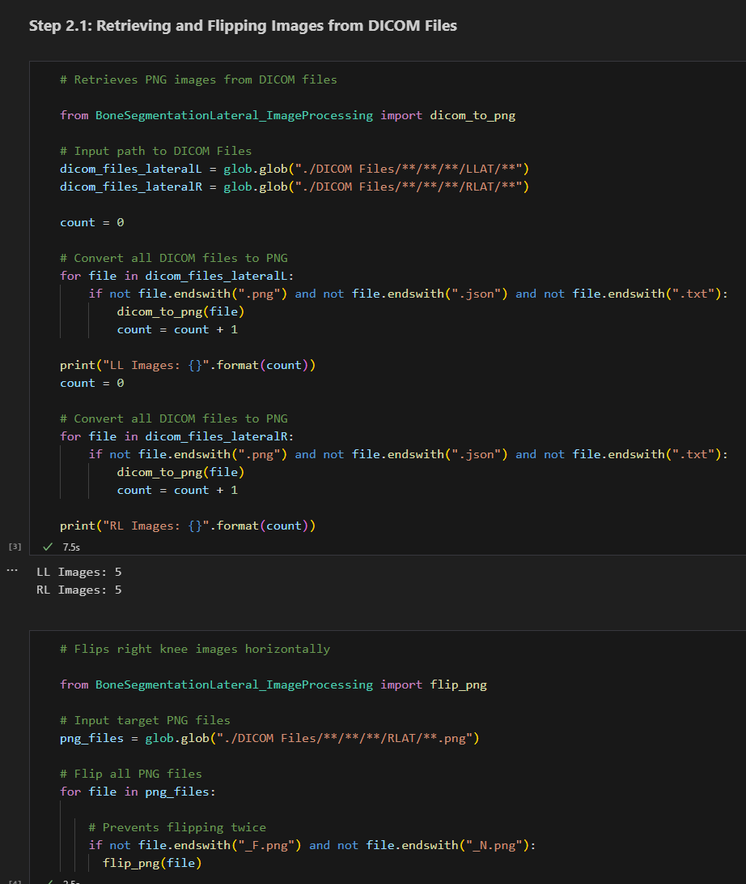

*Figure 2.1.1 “Step 2.1” Section*

### Input: DICOM Files

Edit the strings in this code to change the directories to DICOM files.

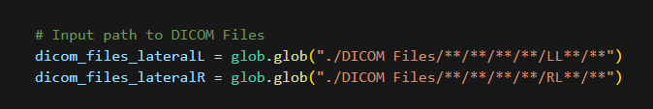

*Figure 2.1.2 “Step 2.1” Sample DICOM Files Input*

### Output: (Flipped) PNG Files

Each image and its flipped image should be stored in the same folder as their respective DICOM files.

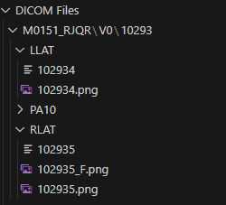 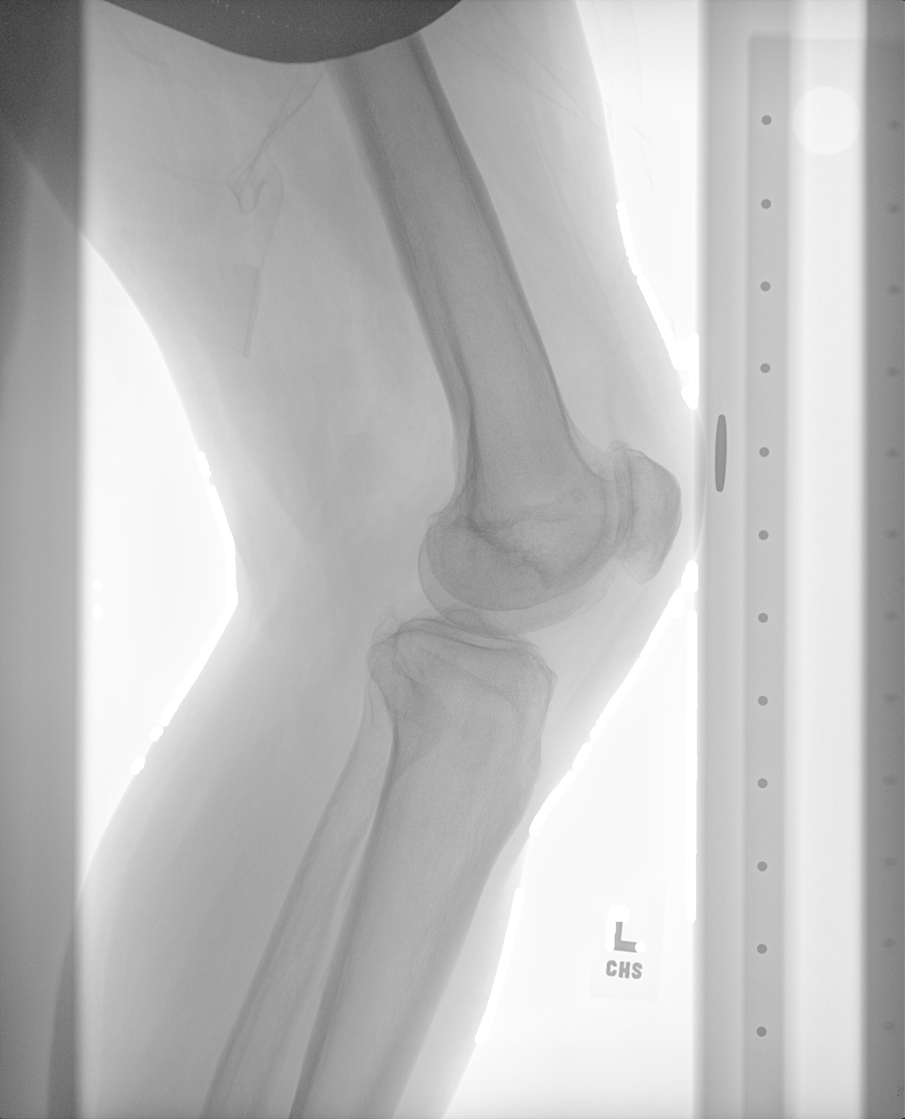

*Figure 2.1.3 “Step 2.1” Sample Output Structure Figure 2.1.4 “Step 2.1” Sample PNG Image*

## 

## 2.2 Cropping Images into Squares

This step uses a pre-trained model to crop the image into a square. The pre-trained model is specifically capable of detecting and cropping lateral knee X-ray images.

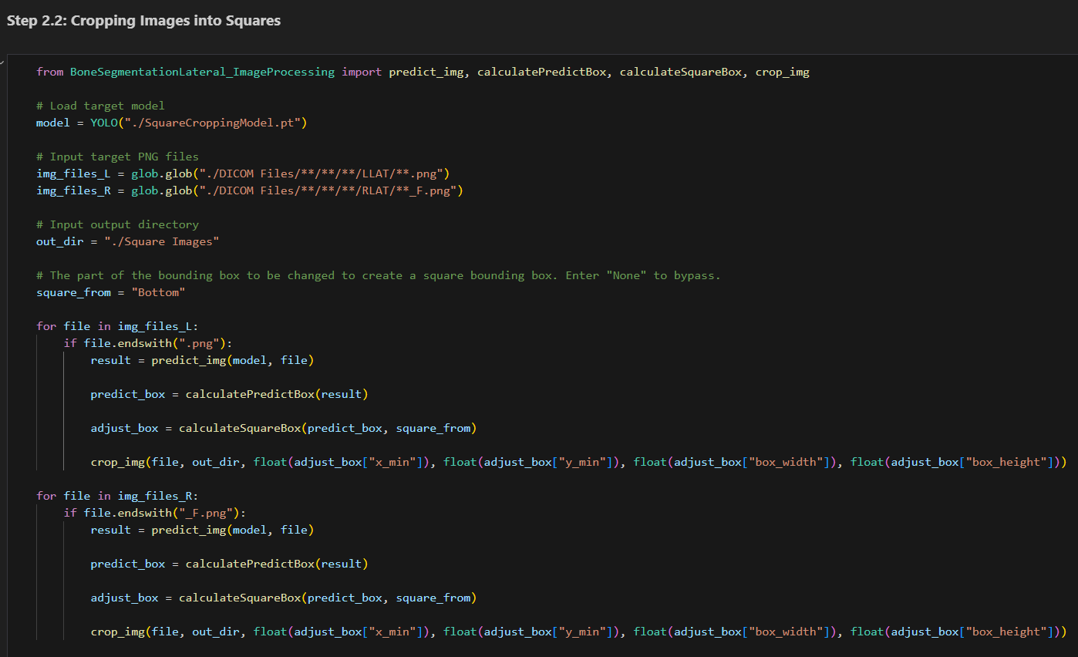

*Figure 2.2.1 “Step 2.2” Section*

### Input: Loaded Model, PNG Files, Output Directory, Customisation

model: A loaded YOLO model. Default is the pre-trained model. Update the string if necessary.

img_files_L / img_files_R: The target PNG files. Update the strings to retrieve the correct target PNG files.

out_dir: The target folder to save the output PNG files. Update the string to change the target folder.

square_from: Controls how the square is cropped. Do not change this input if using the pre-trained model.

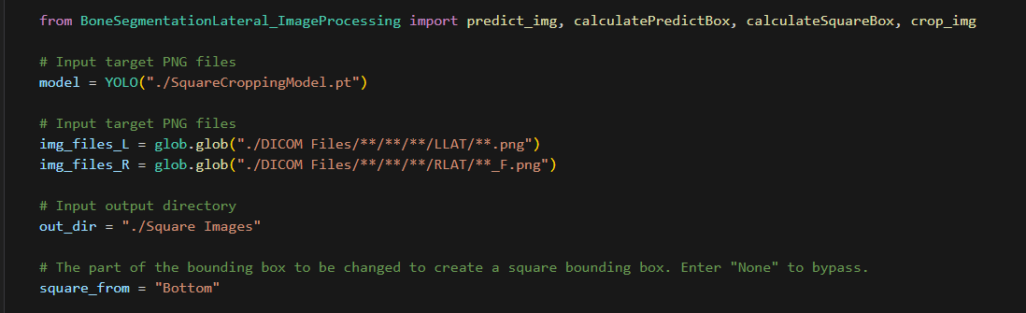

*Figure 2.2.2 “Step 2.2” Sample Input Parameters*

### Output: Cropped PNG Files:

The text files should be stored in the targeted folder, with the same file name as the original PNG file.

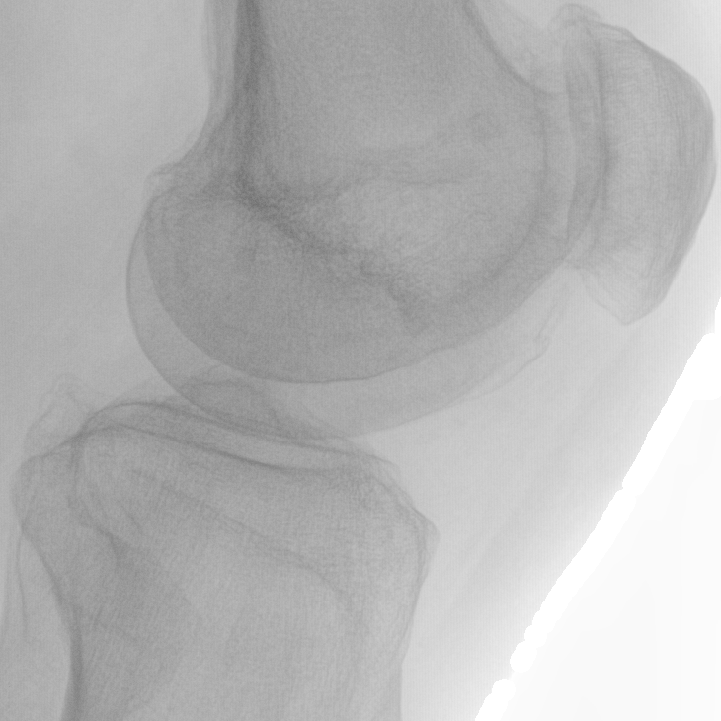

*Figure 2.2.3 “Step 2.2” Sample Output Image*

## 

## 2.3 Processing Square Images

This step includes normalisation and applying CLAHE normalisation to create a clearer image.

Normalisation improves YOLO training performance, while CLAHE normalisation aids labelling by enhancing contrast.

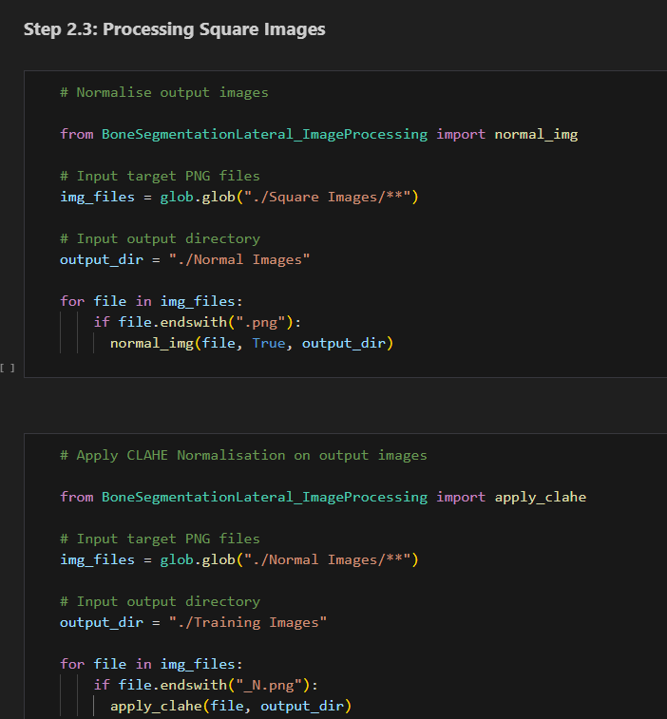

*Figure 2.3.1 “Step 2.3” Section*

### Input: PNG Files

For both sections,

img_files: The target PNG files. Update the string to retrieve the correct target PNG files.

out_dir: The target folder to save the output PNG files. Update the string to change the target folder.

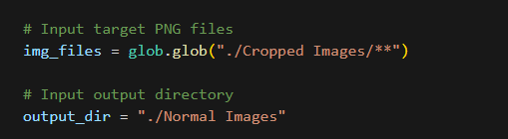

*Figure 2.3.2 “Step 2.3” Sample normal_img() Input Parameters*

### Output: (CLAHE) Normalised PNG File

The images should be stored in the targeted folder, with “_N.png” added as a suffix.

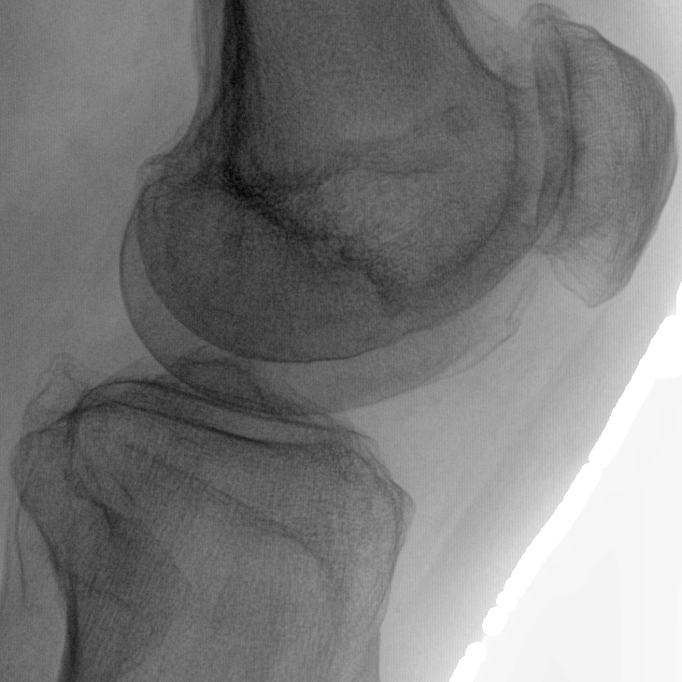

*Figure 2.3.3 “Step 7.3” Sample normal_img() Output Image*

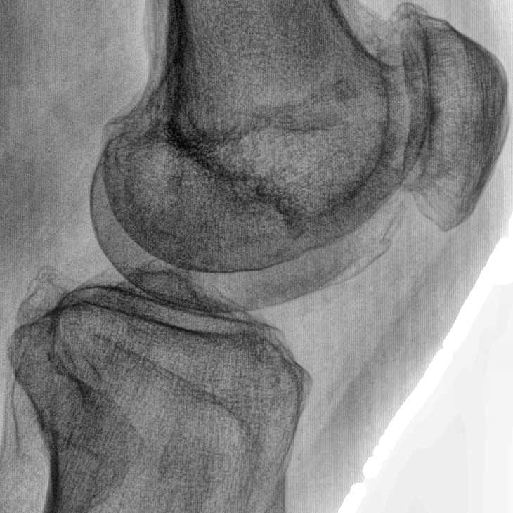

*Figure 2.3.4 “Step 7.3” Sample apply_clahe() Output Image*

# Step 3: Creating Bounding Boxes with LabelMe

LabelMe is the main program used to create the polygon area of the bones. These steps provide a guide to using LabelMe for this program.

## 3.1 Initialising LabelMe

1. Start “Anaconda Prompt”
2. Type and execute: “labelme”

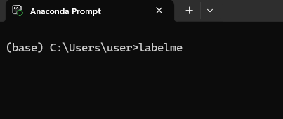

*Figure 3.1.1 Opening LabelMe with Anaconda Prompt*

If LabelMe successfully initialises, the LabelMe GUI will open:

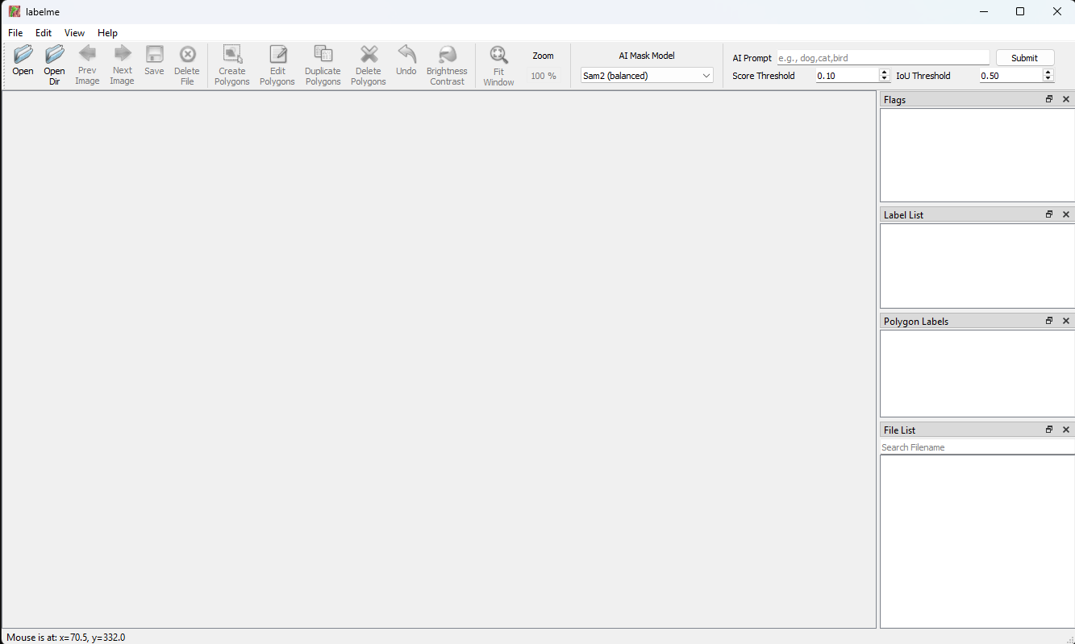

*Figure 3.1.2 LabelMe GUI*

Anaconda Prompt should report feedback from opening LabelMe:



*Figure 3.1.3 Anaconda Prompt Feedback*

## 3.2 Opening Image Directory

1. Select “Open Dir” or input [Ctrl+U]

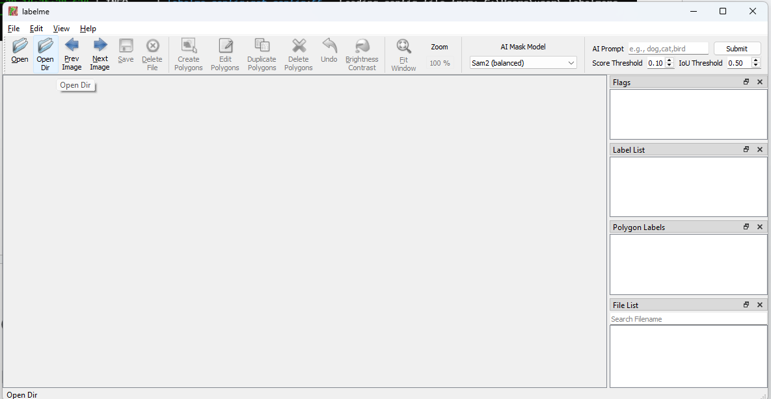

*Figure 3.2.1 LabelMe “Open Dir” Button*

1. Select the folder containing your images

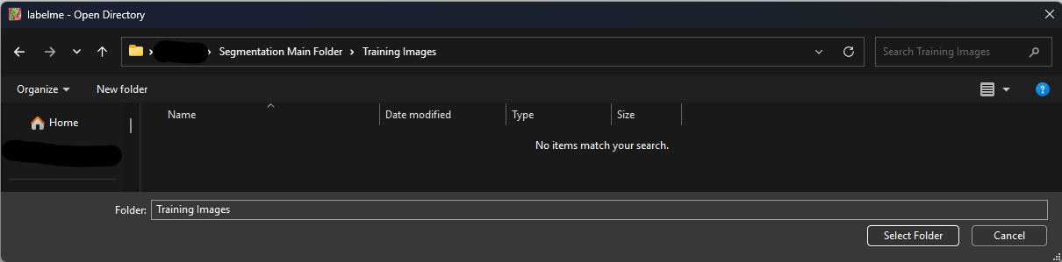

*Figure 3.2.2 LabelMe Open Directory*

If opening the directory is successful, this should be the resulting screen shown in LabelMe.

The image files and their JSON files can be accessed through the “File List” Box at the bottom right.

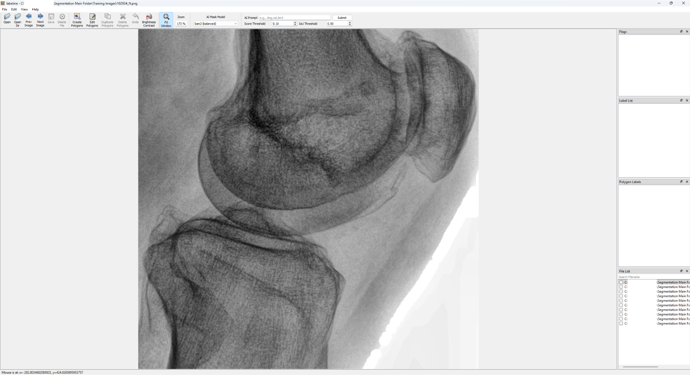

*Figure 3.2.3 LabelMe GUI After Opening Directory*

## 3.3 Drawing Polygon Bounding Box

The notebook requires bounding box information created by the “Create Polygon” tool.

Errors may occur if other tools are used instead.

Please create the polygons in consistent order. For example, label “Patella” > “Femur” > “Tibia” for all images.

Use “Create Rectangle” Tool: [Right click -> Create Polygons] or [Ctrl+N]

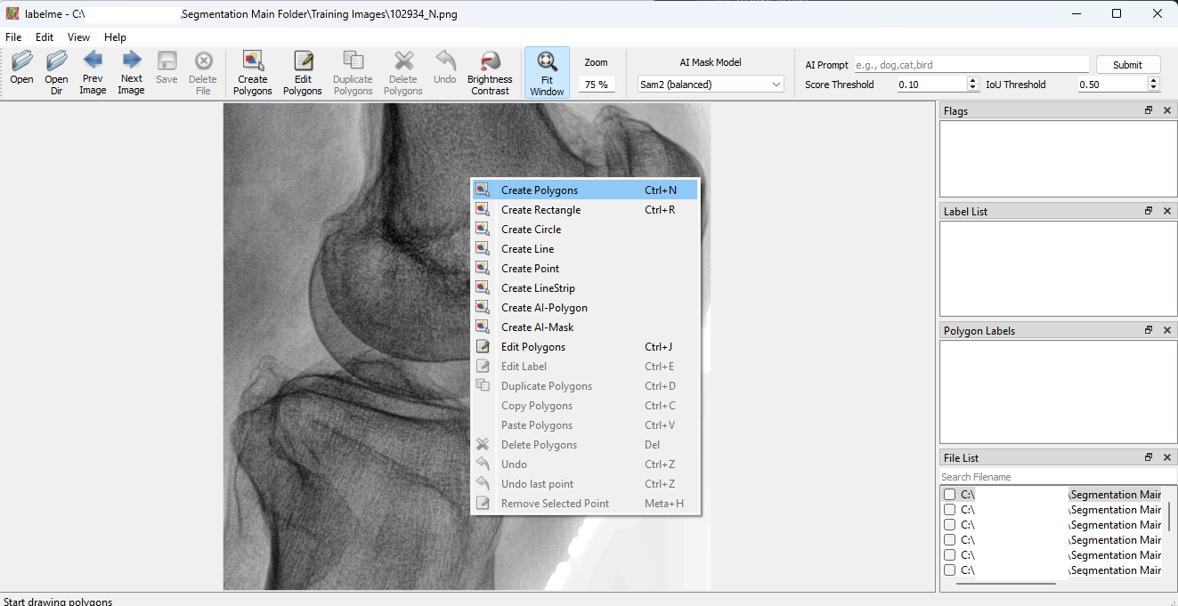

*Figure 3.3.1 “Create Polygon” in Right-Click Menu in LabelMe*

Drawing Polygon:

1. Click along the edge of the bone.
2. Name the object label.

(Use consistent naming! For the demonstration, “Patella”, “Femur”, ”Tibia” is used.)

1. Select “OK” or input [Enter] to confirm.

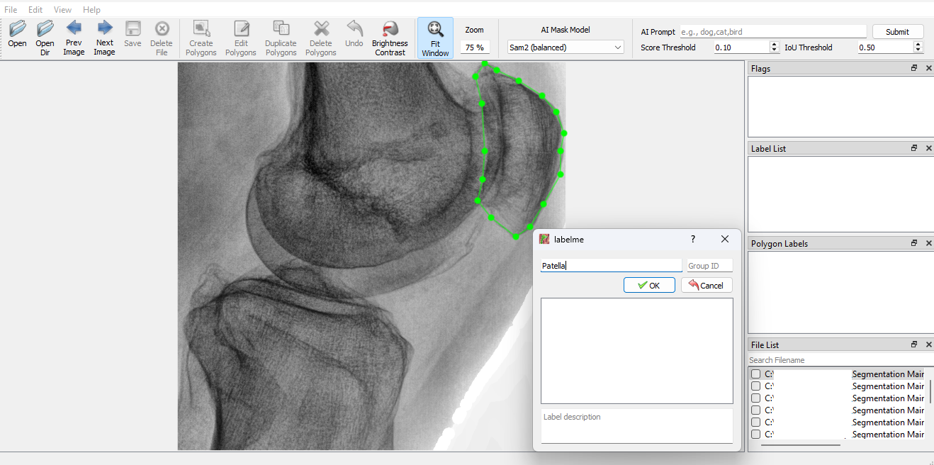

*Figure 3.3.3 Creating a Polygon in LabelMe*

Editing Polygon:

1. Select “Edit Polygons” on the Toolbar or input [Ctrl+J].
2. To move a point, click and drag the point.
3. To add a point, hold [alt] and click at the position for the point.
4. To remove a point, hold [alt+shift] and click at the point.

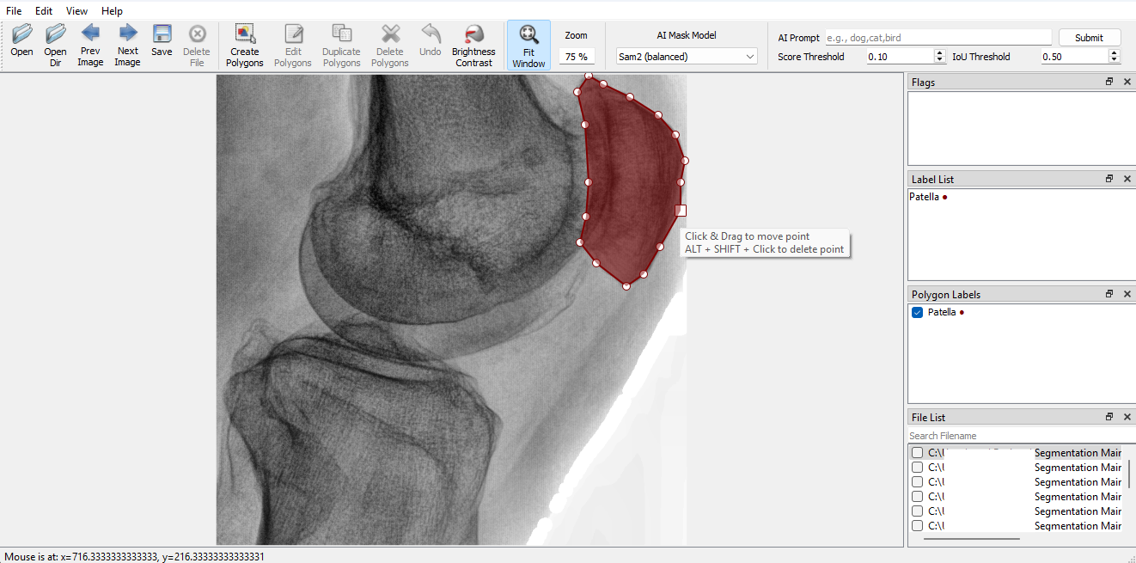

*Figure 3.3.4 Editing a Polygon in LabelMe*

## 3.4 Saving Bounding Box

1. Select “Save” on the Toolbar or input [Ctrl+S].
2. Save the file **without** changing the file name or file type.

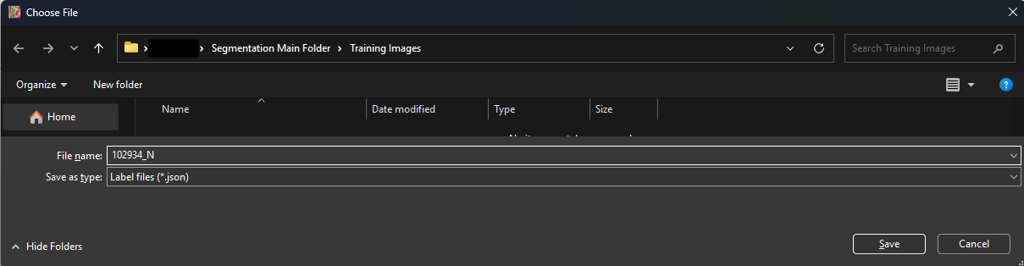

*Figure 3.4.1 Saving JSON File in LabelMe*

Images with a saved JSON file will have a blue checkmark. Further saving will save the updated information into the same JSON file.

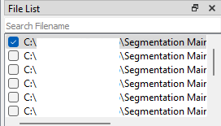

*Figure 3.4.2 Checkmark at Image with Saved JSON file in File List in LabelMe*

**Note:** Please make sure that the file name is unedited and is a JSON file.

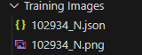 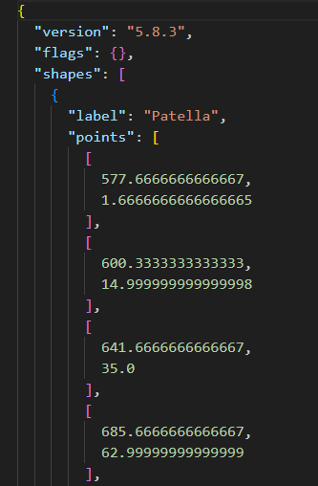

*Figure 3.4.3 Sample Folder Structure after Saving Figure 3.4.4 Sample JSON File Contents*

# Step 4: Creating YOLO Required Dataset

These steps convert the current images and labels into a dataset required for training a YOLO model.

## 4.1 Splitting Training and Inference Images

The training and inference images with their JSON files should be split into the folders “Training Folder” and “Inference Folder” now.

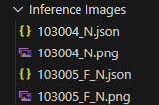 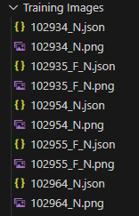

*Figure 4.1.1 Sample “Inference Images” Structure Figure 4.1.2 Sample “Training Images” Structure*

## 4.2 Creating YOLO Dataset

This step converts LabelMe JSON files to YOLO TXT files, which are required for YOLO training. In addition, this separates each class into an individual image, as YOLO does not support multiple classes for a single pixel.

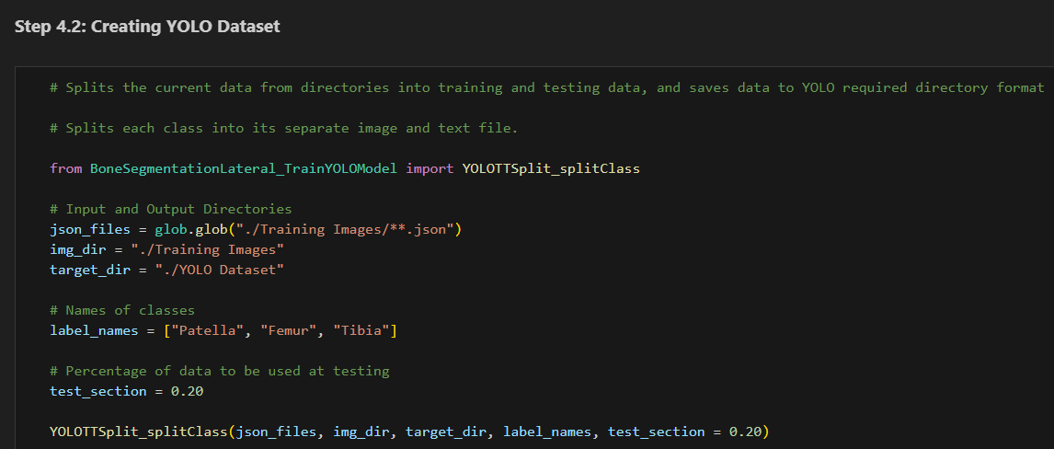

*Figure 4.2.1 “Step 4.2” Section*

### Input: JSON files, Image Directory, Target Directory, Label Names, Percentage

image_dir: The target folder with the PNG files. Update the string to change the target folder.

txt_dir: The target folder with the TXT files containing the bounding box label. Update the string to change the target folder.

target_dir: The target folder to save the dataset. Update the string to change the target folder.

label_names: The names of classes used, in the order of their index.

test_section: The percentage of test data used in validation.

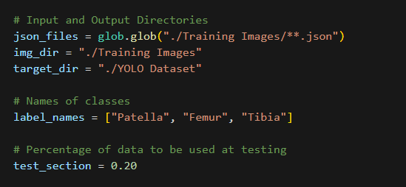

*Figure 4.2.2 “Step 4.2” Sample Input Parameters*

### Output: YOLO Dataset

The YOLO dataset in the required format will be copied into the target folder.

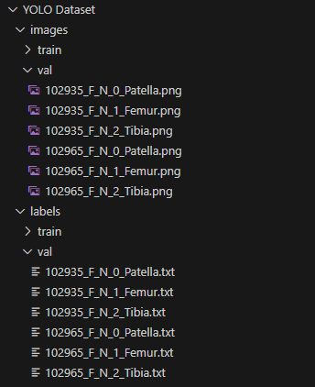

*Figure 4.2.3 “Step 4.2” Sample Output Structure*

## 4.4 Creating YOLO YAML file

This step creates or updates a YAML file, which is required to direct the model trainer to the dataset.

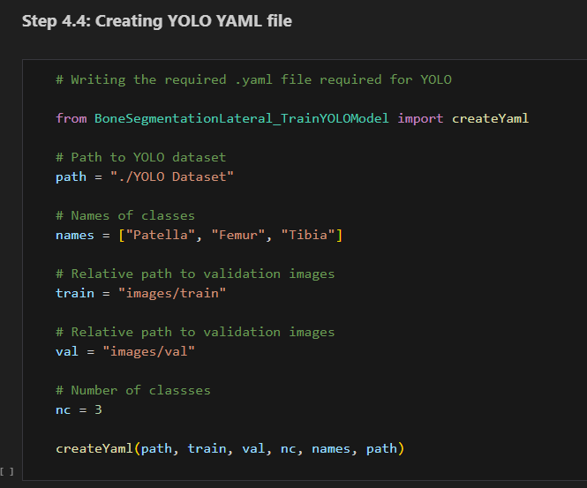

*Figure 4.4.1 “Step 4.4” Section*

### Input: YAML Required Information

path: The target folder with the YOLO Dataset. Update the string to change the target folder.

names: The name of the classes used. Should be the same as label_names in Step 4.2.

nc: Number of classes. Should be consistent with the number of items in names.

train, val: Relative path to training and validation images. Should remain unchanged if Steps 4.1 and 4.2 were used to create the dataset.

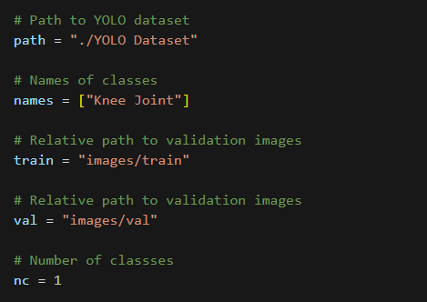

*Figure 4.4.2 “Step 4.4” Sample Input Parameters*

### Output: YAML File

The YAML File will be updated or added to the folder with the YOLO Dataset.

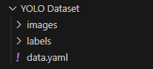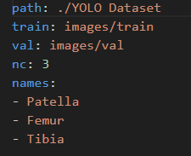

*Figure 4.4.3 “Step 4.4” Sample Output Structure & YAML File*

# Step 5: Fine-tuning YOLO Model

These steps fine-tune a YOLO11 nano segmentation model, along with a guide to understand the output metrics of the training.

## 5.1 Fine-Tuning New Model

This step fine-tunes a pre-trained YOLO11 nano segmentation model with the dataset.

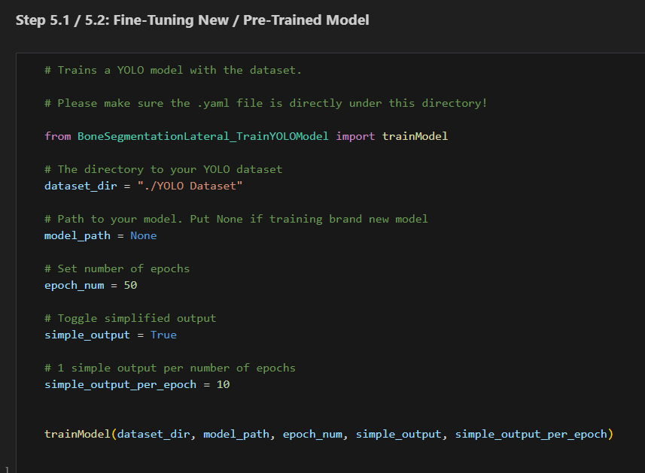

*Figure 5.1.1 “Step 5.1/5.2” Section*

### Input: Dataset Directory, Training Parameters

dataset_dir: The target folder with the YOLO Dataset. Update the string to change the target folder.

model_path: **None**. This option is used for training a new model.

epoch_num: Number of epochs used in training.

simple_output: If True, activates a custom-made output system with a text file.

simple_output_per_epoch: Number of epochs before generating an output in the custom output system.

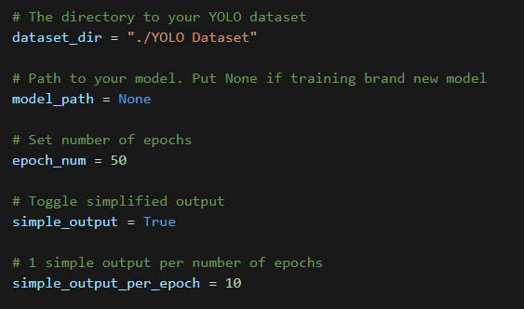

*Figure 5.1.2 “Step 5.1/5.2” Sample Input Parameters*

### Output: Completed Model Run Folder

A new folder “runs\segment\train” should appear with data shown in Figure 5.1.3 in the main folder.

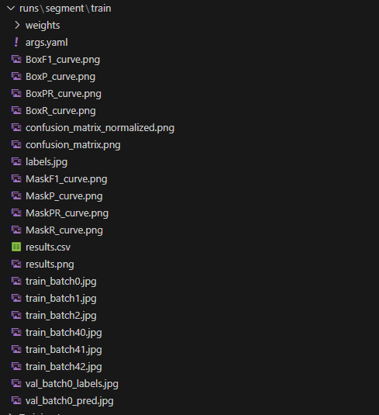

*Figure 5.1.3 “Step 5.1/5.2” Sample Training Output*

For the details of this output, please refer to Step 5.3.

### Simple Output System:

A new text file “custom_output.txt” will be added to the YOLO dataset folder.

For every epoch, the following information will be collected and combined into a single JSON file.

* Best Fitness
* Box loss and the lowest box loss achieved
* Segmentation (Seg) loss and the lowest segmentation loss achieved
* Classification (Cls) loss and the lowest classification loss achieved
* Distributed focal loss (Dfl) and the lowest distributed focal loss achieved
* Box precision, recall, mAP50 and mAP50–95 and their highest achieved value
* Mask precision, recall, mAP50 and mAP50–95 and their highest achieved value

For the details of these metrics, please refer to Step 5.3.

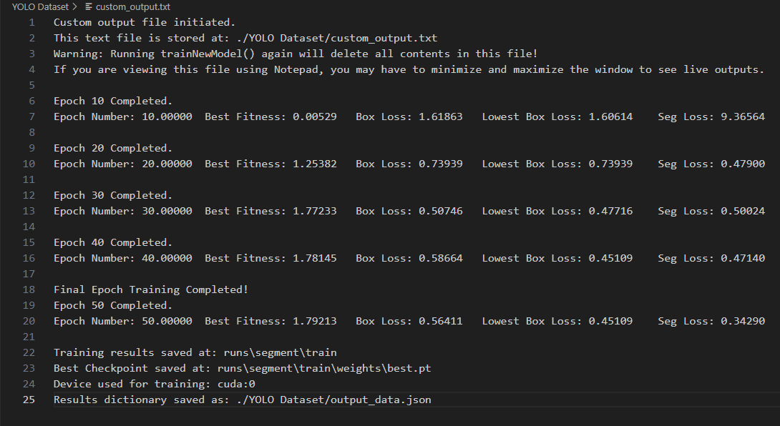

*Figure 5.1.4 Sample Simple Output System Output (Contents of custom_output.txt)*

As seen in Figure 5.1.4, the paths for storing:

* This text file
* Training results
* Best model checkpoint (model at epoch with best performance)
* Epoch data (output_data.json)

And the device used for training will also be printed.

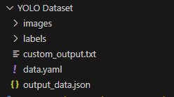

*Figure 5.1.5 Sample YOLO Dataset Folder Structure after Output*

## 5.2 Re-training Trained Model

To train a saved model, input the path of the target model in the model_path parameter in Step 5.1.

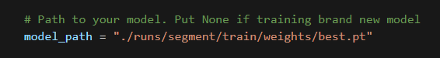

*Figure 5.2.1 “Step 5.1/5.2” Sample model_path Input to Train Saved Model*

The input parameters, functionality, and outputs are identical to those in Step 5.1. Please refer to Step 5.1.

## 5.3 Interpreting Training Results

| Metric Type: | Calculated based on: |
| --- | --- |
| Box- | The rectangular bounding box containing the labelled shape. |
| Mask- | Directly compare the labelled shape between prediction and ground truth. |
| Train- | Metrics gathered with training images. |
| Val- | Metrics gathered with validation images. |

*Figure 5.3.1 Table of Types of Metrics*

| Loss Metrics: | Calculation: | Significance: |
| --- | --- | --- |
| Box Loss (box_loss) | Complete Intersection over Union (IoU) | Addresses correctly indicating the bounding box position |
| Segmentation Loss (seg_loss) | Combining Binary Cross Entropy (BCE) and Dice Coefficient | Addresses the similarity between the shape of the prediction and the ground truth |
| Classification Loss (cls_loss) | Binary Cross Entropy (BCE) | Addresses correctly classifying detected objects |
| Distributed Focal Loss (dfl_loss) | Unknown | Addresses discerning background and target object |

*Figure 5.3.2 Table of Loss Metrics*

| Performance Metrics: | Definition: | Significance: |
| --- | --- | --- |
| Precision | Accuracy of detected objects. | Indicates the number of correct predictions. |
| Recall | Ability to detect all objects. | Indicates cases of false negatives. |
| mAP50 | Mean Average Precision (mAP) with an IoU threshold of 0.5. | The accuracy of predicting easier objects. |
| mAP50-95 | Average value between mAP50, mAP55, until mAP95. | A stricter value shows the accuracy of predicting more difficult objects. |

*Figure 5.3.2 Table of Performance Metrics*

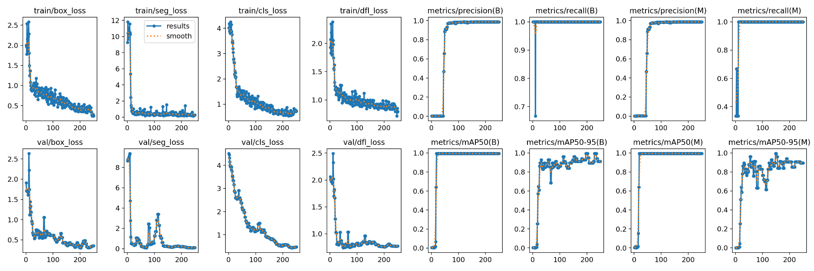

*Figure 5.3.4 Sample “results.png” Containing Curves of Metrics*

Curves:

| Curves: | Definition: |
| --- | --- |
| F1-Confidence | Harmonic mean of precision and recall at different confidence levels. |
| Precision-Confidence | Values of precision for different confidence values. |
| Recall-Confidence | Values of recall for different confidence values. |
| Precision-Recall | Relationship between precision and recall. |

*Figure 5.3.5 Table of Types of Curves*

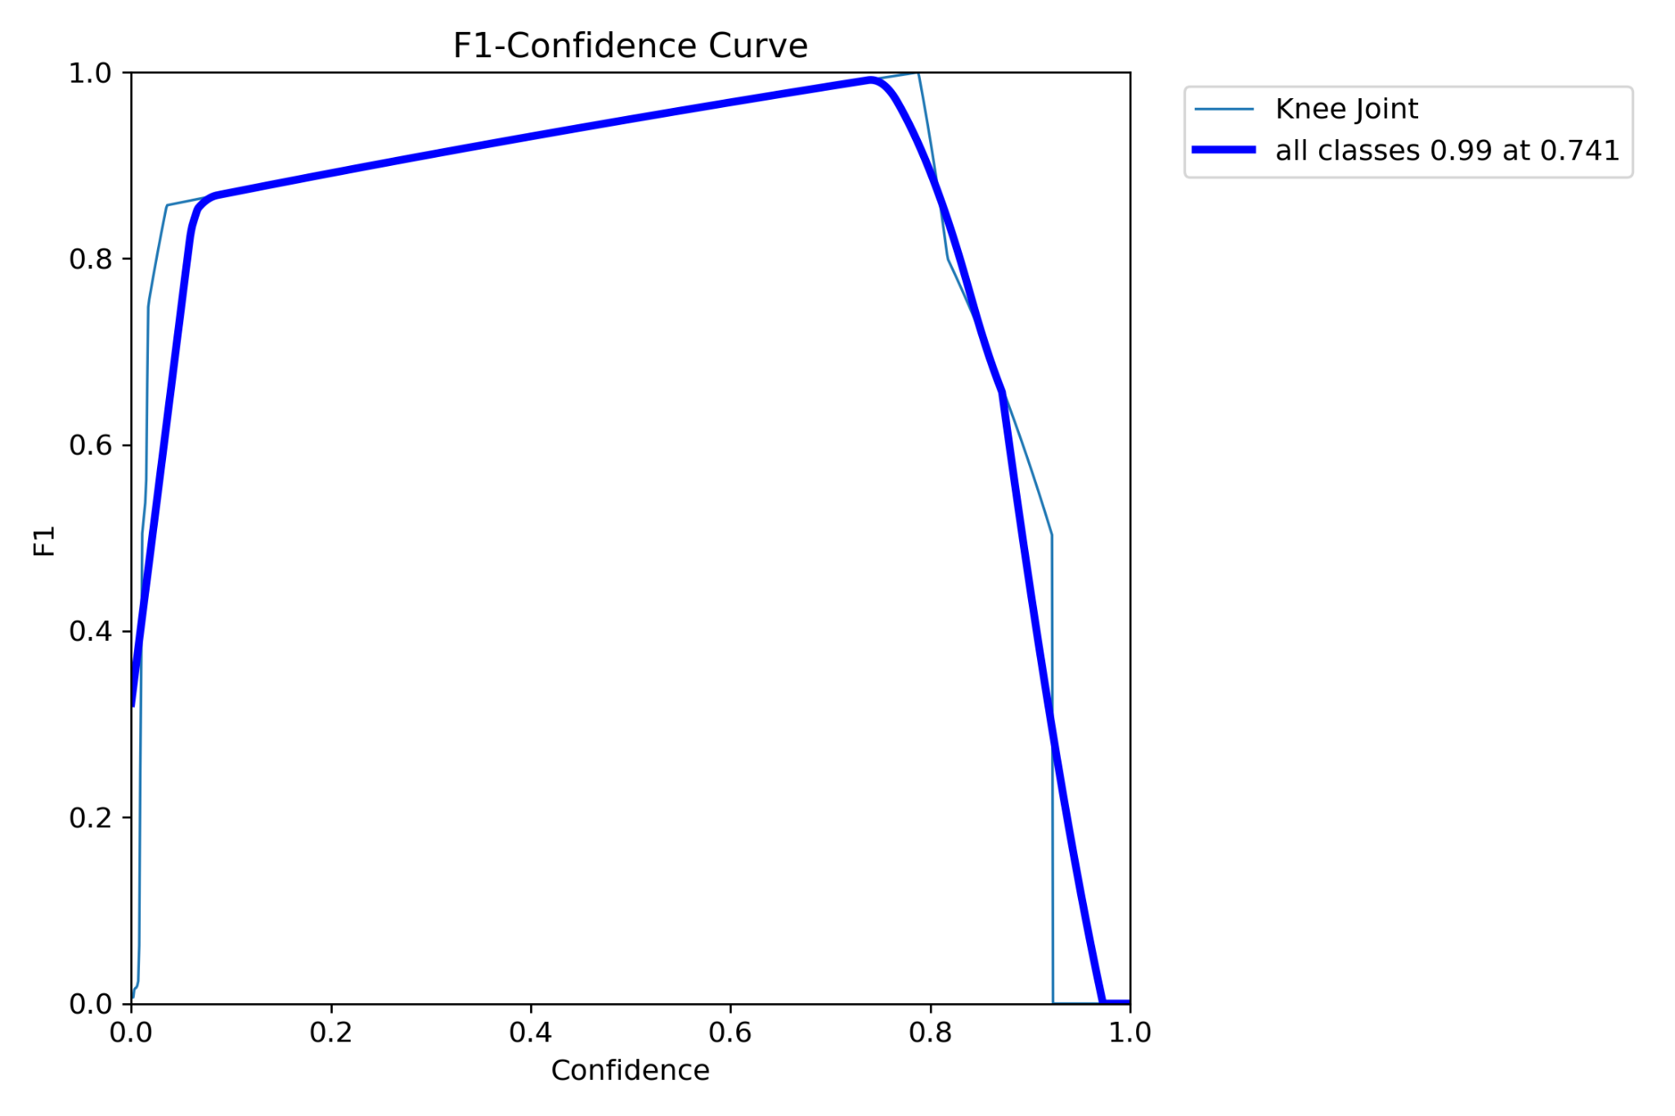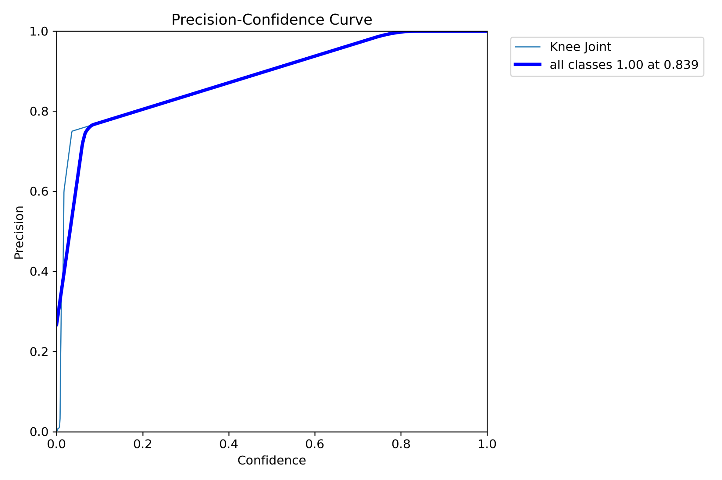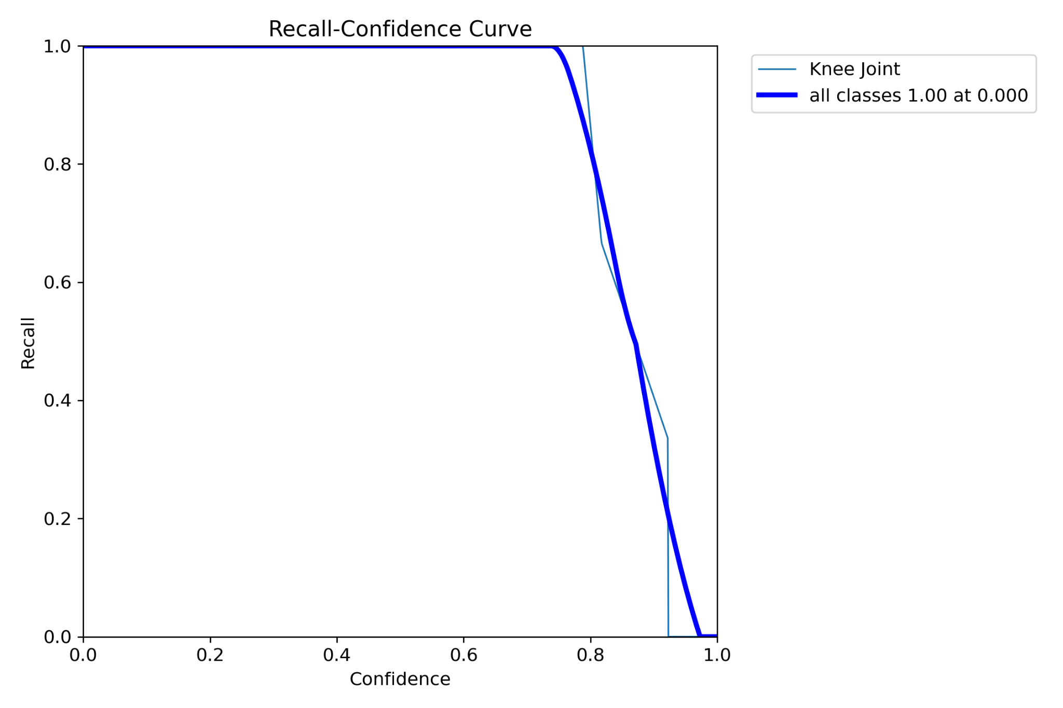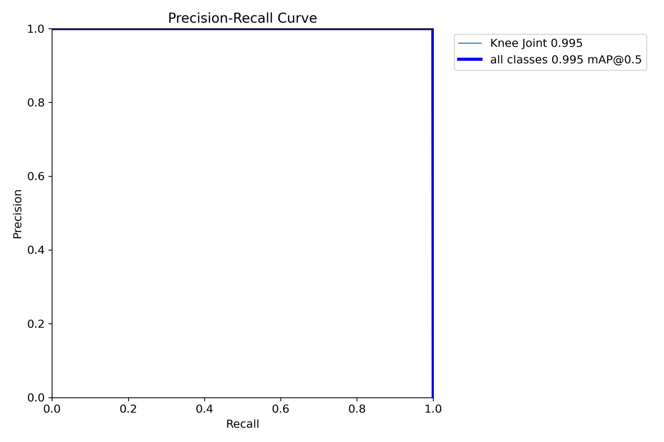

*Figure 5.3.6 Sample* F1-Confidence, Precision-Confidence, Recall-Confidence, Precision-Recall Graphs

Predictions:

train_batch.jpg: Images with the ground truth labelled. These images are used for training the model, and may appear jumbled or irregular due to automatic image augmentation by the YOLO trainer.

Only the first and last 3 train_batch images will be saved.

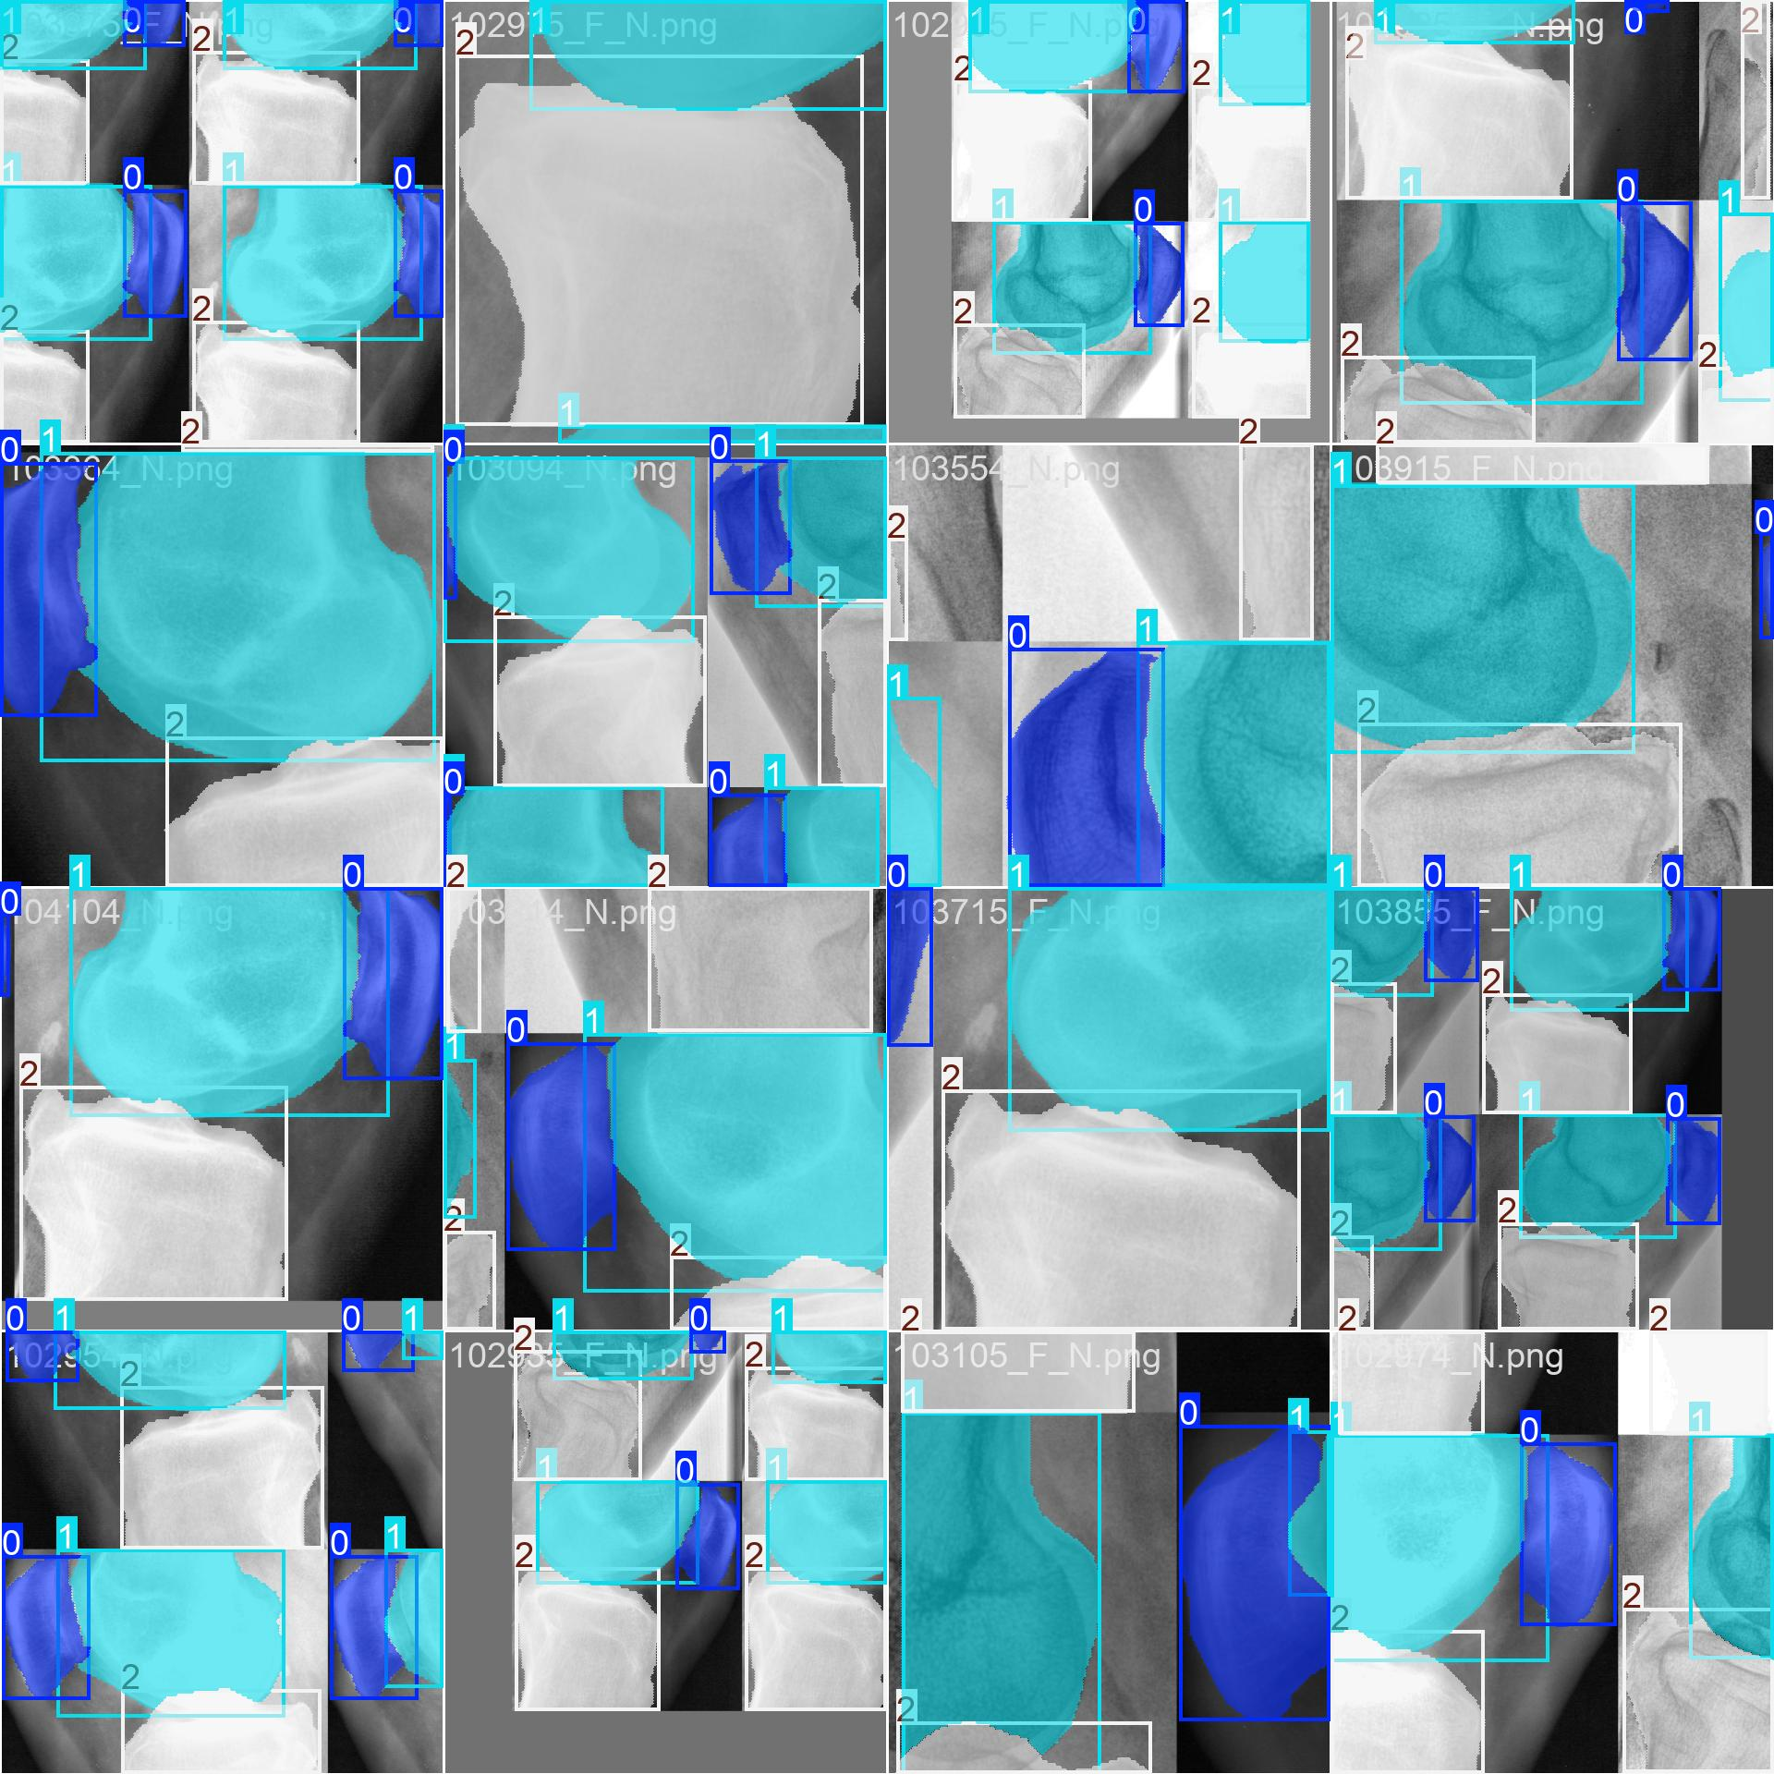

*Figure 5.3.7 Sample “train_batch0.jpg”*

val_batch0_pred.jpg: Images with prediction made with the model. The class label and confidence will also be labelled.

val_batch0_labels.jpg: Images with the ground truth labelled. Compare with val_batch0_pred.jpg to evaluate the model’s performance.

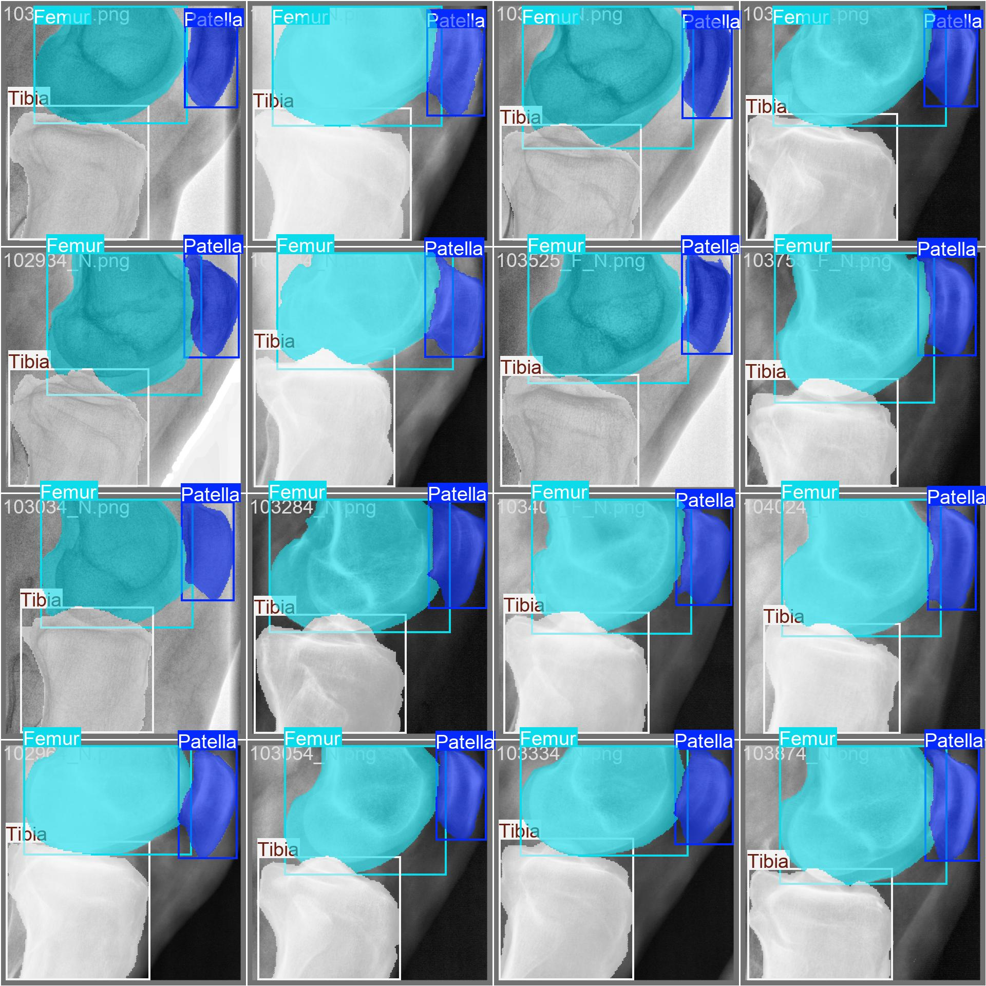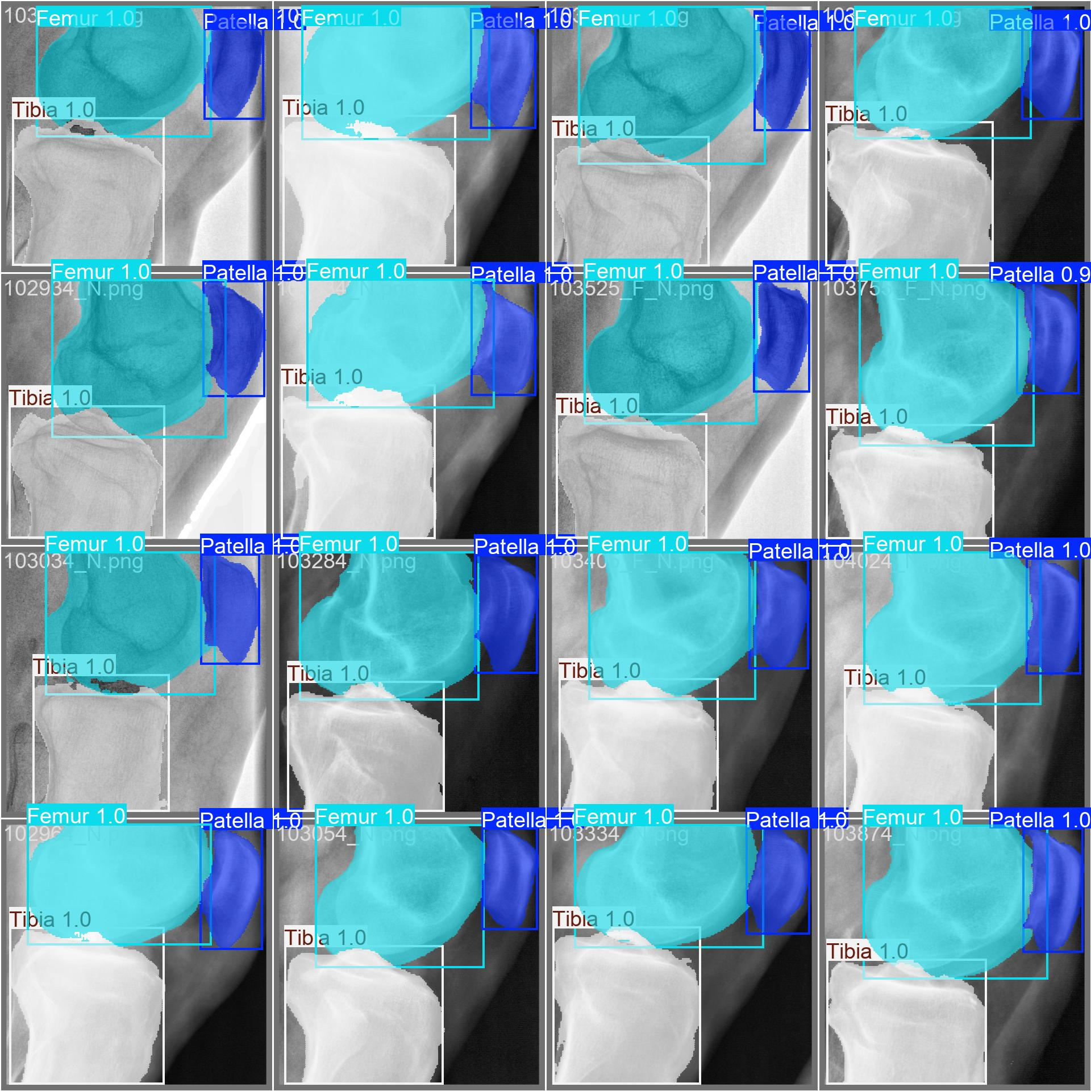

*Figure 5.3.8 Sample “*val_batch0_labels.jpg*” (left) and “*val_batch0_pred.jpg*” (right)*

For the images, the boundaries of each bone at the intersections may be obstructed or inaccurate. This is due to YOLO being unable to assign multiple class labels to a single pixel. The model is still able to recognise each bone separately.

If the graphs in results.png are not clear enough, or the shape is obstructed by random high outliers:

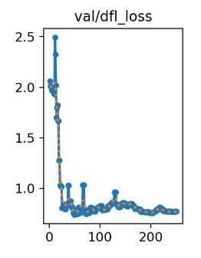

*Figure 5.3.9 Sample “val/dfl_loss” graph with high outlier*

Consider running extraResultPlots() in Step 5.3 to generate graphs at a larger scale.

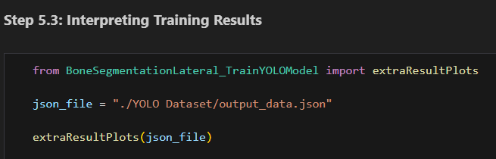

*Figure 5.3.10 “Step 5.3” Section*

### Input: JSON File

Input the path to the JSON file generated by Step 5.1 or 5.2.

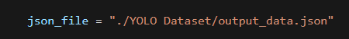

*Figure 5.3.11 “Step 5.3” Sample Input Parameter*

### Output: 5x5 Matplotlib Plot

A Matplotlib plot should be outputted with 25 graphs in a 5x5 format.

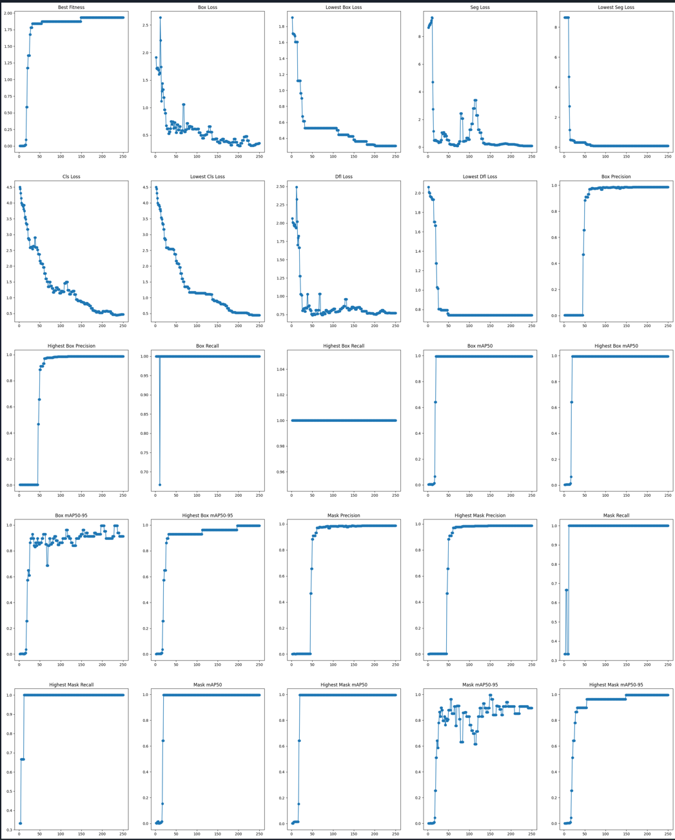

*Figure 5.3.12 “Step 5.3” Sample Output Plot*

# Step 6: Inference with Tuned Model

These steps run an inference test with completely new images, testing the performance and capabilities of the trained model.

## 6.1 Running Inference

This step contains the inference program. Inference images are passed through the model, and statistics are returned.

### Input: Loaded model, Input Parameters, Plotting parameters

model: A loaded YOLO model. Update the string to the path to your model.

img_dir: The directory to your PNG files. Update the string to retrieve the correct target PNG files.

json_dir: The directory to your LabelMe JSON files. This should be the same as img_dir.

mask_output_dir: The directory to output mask images of predictions.

truth_output_dir: The directory to output mask images of the ground truth.

label_names: The names of the classes used. Should be the same as label_names in Step 4.2.

plot_size: The length of each square plot in inches.

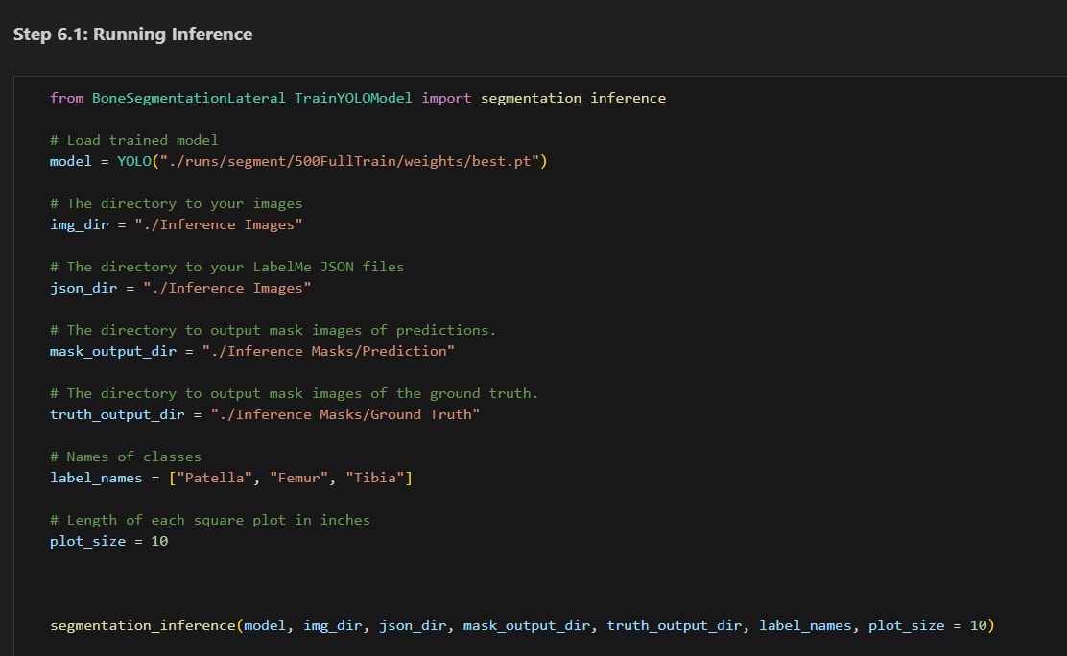

*Figure 6.1.1 “Step 6.1” Section*

### Output: Matplotlib Plot, Printed Statistics, Mask Images

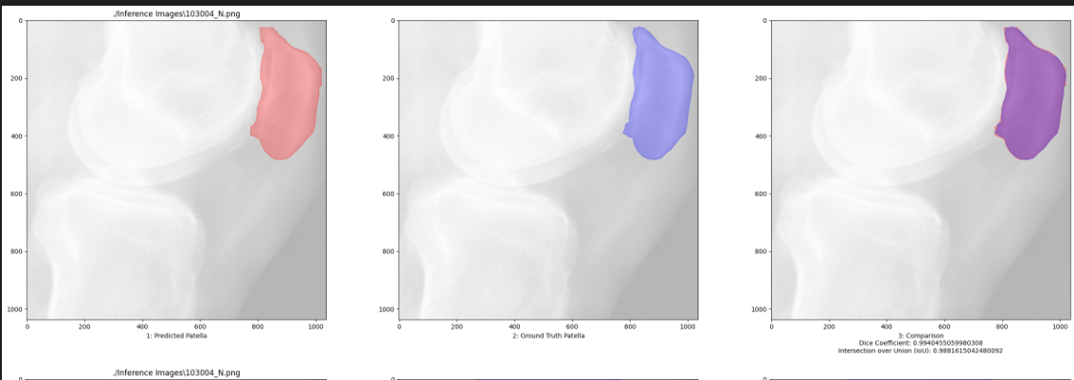

*Figure 6.1.2 “Step 6.1” Sample Output Plot*

In Figure 6.1.2, the left red mask is the prediction generated by the model. The centre blue mask is the area labelled as the ground truth. The two masks are overlaid above each other at the rightmost plot. The purple area represents the intersecting area. The dice coefficient and intersection over union values are given below.

This comparison is generated for every class predicted in the prediction, with each row representing a class.

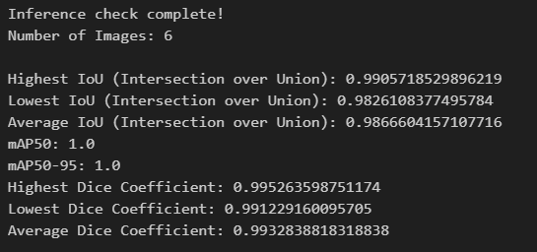

*Figure 6.1.3 “Step 6.1” Sample Printed Output*

Additional statistics will be printed for recording, as shown in Figure 6.2.3.

All mask images will be output in the provided directories, with a separate image file for each class.

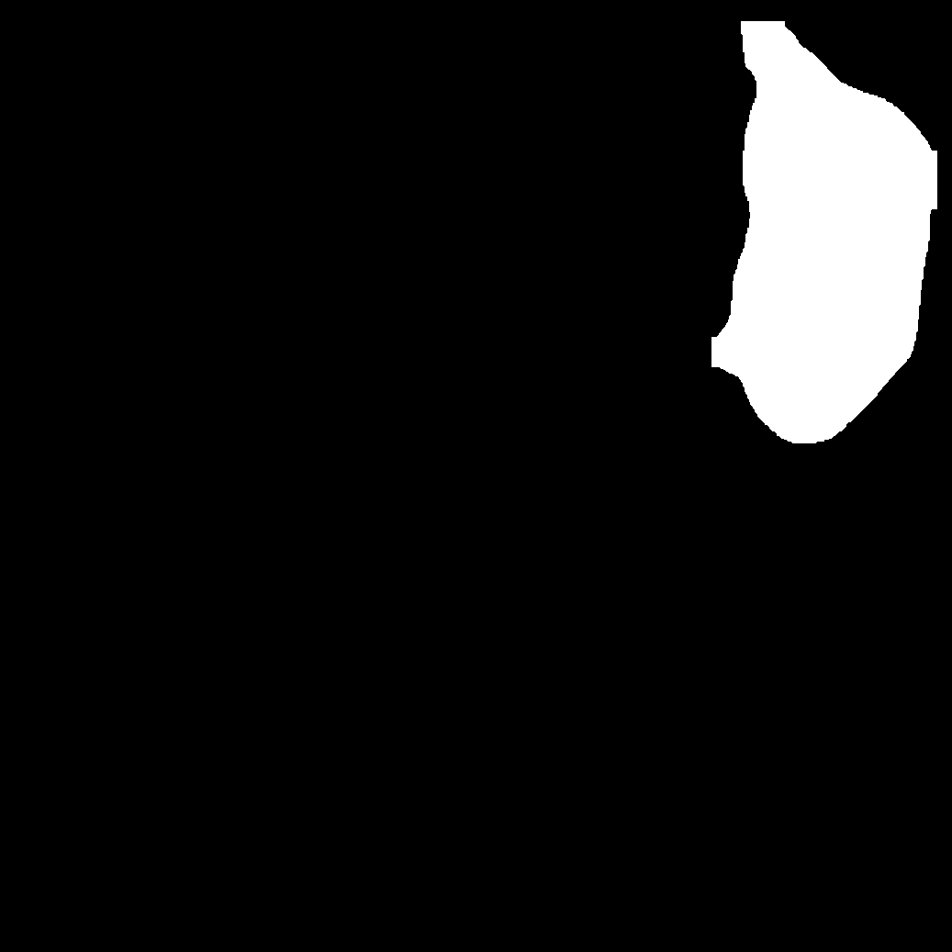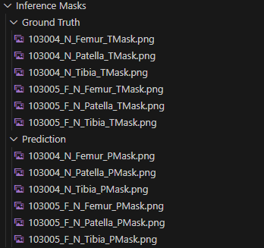

*Figure 6.1.4 “Step 6.1” Sample Prediction Mask Image (Left) & Sample Output Structure (Right)*

To produce the masks, the following editing is applied:

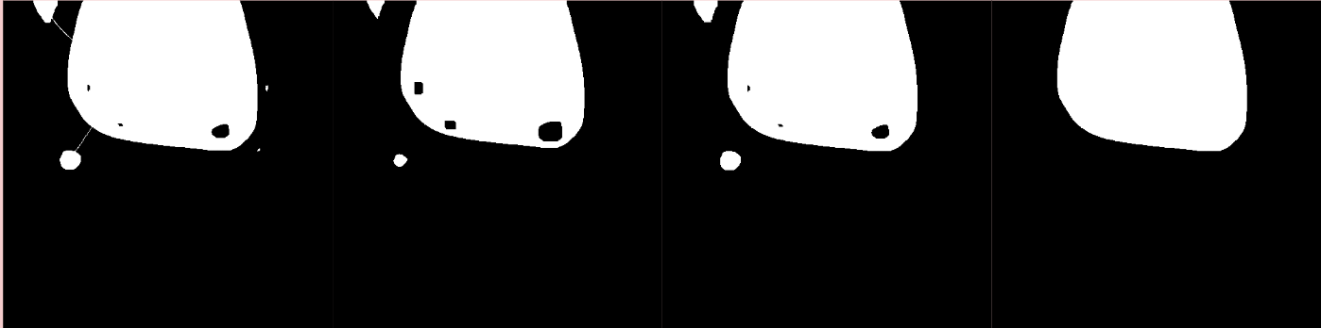

*Figure 6.1.5 “Step 6.1” Sample Mask Editing Process*

* 1st Shape: Original Image
* 2nd Shape: Erosion applied
  + Removes small connections between areas
  + Removes small noise
* 3rd Shape: Dilation applied
  + Estimates and returns to the original area before dilation
* 4th Shape: Largest area
  + Final Image

# Step 7: Creating Mask Images with Tuned Model

If inference yielded successful or expected results, the model can be used to generate mask images for each class detected.

## 7.1 Creating Mask Images

This step generates an individual mask image for each class detected for every image.

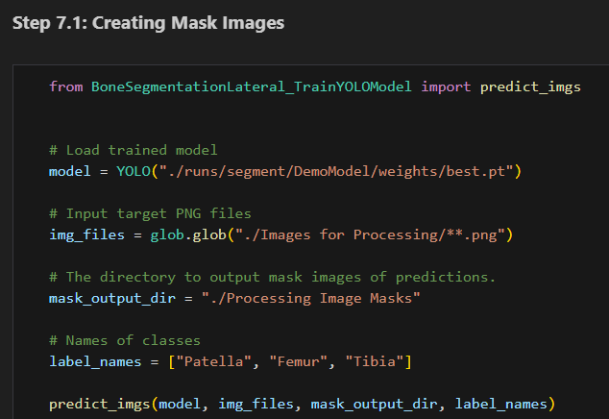

*Figure 7.1.1 “Step 7.1” Section*

### Input: Loaded Model, PNG Files, Output Directory, Customisation

model: A loaded YOLO model. Update the string to the path to your model.

img_files: The target PNG files. Update the string to retrieve the correct target PNG files.

mask_output_dir: The directory to output mask images of predictions.

label_names: The names of the classes used. Should be the same as label_names in Step 4.2.

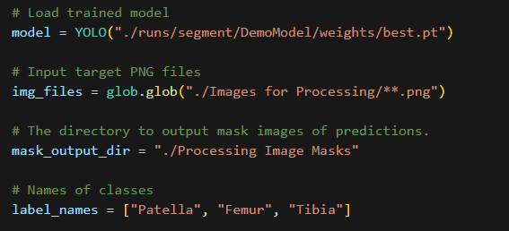

*Figure 7.1.2 “Step 7.1” Sample Input Parameters*

### Output: Cropped PNG Files:

The mask image files should be stored in the targeted folder.

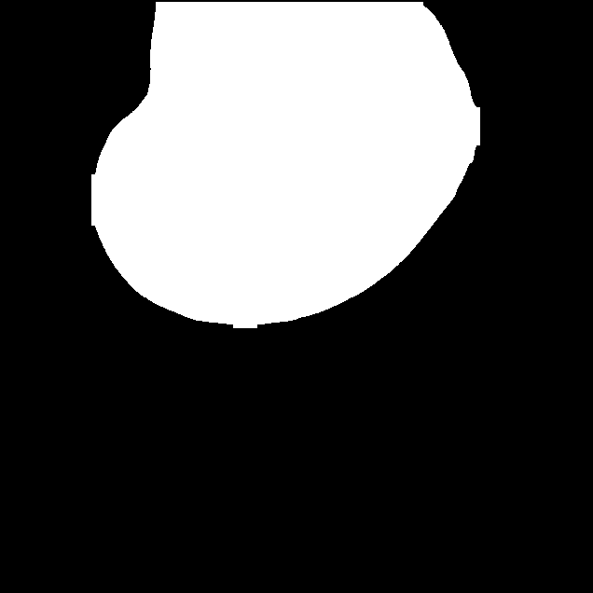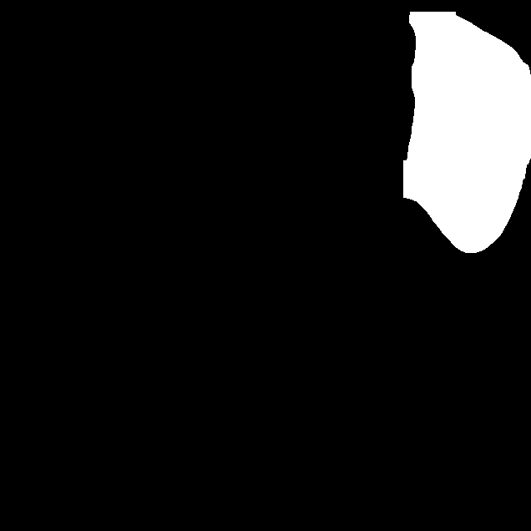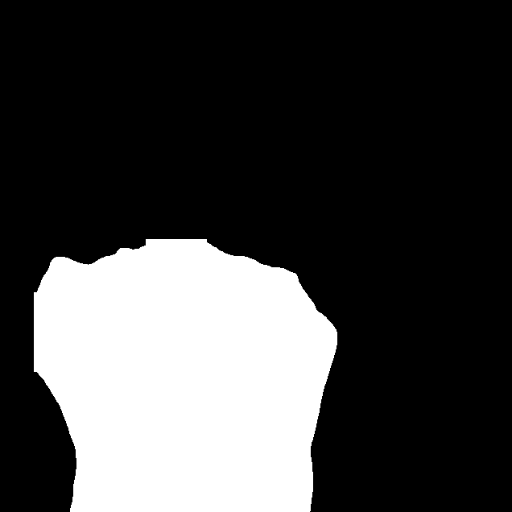

*Figure 7.1.3 “Step 7.1” Sample Output Images*

# 

# Conclusion

The program was able to train a YOLO segmentation model that was able to identify and detect the area of the patella, femur and tibia. The program was then able to generate mask images for each bone within the image.

# Acknowledgement:

@software{yolov8_ultralytics,

author = {Glenn Jocher and Ayush Chaurasia and Jing Qiu},

title = {Ultralytics YOLOv8},

version = {8.0.0},

year = {2023},

url = {https://github.com/ultralytics/ultralytics},

orcid = {0000-0001-5950-6979, 0000-0002-7603-6750, 0000-0003-3783-7069},

license = {AGPL-3.0}

}